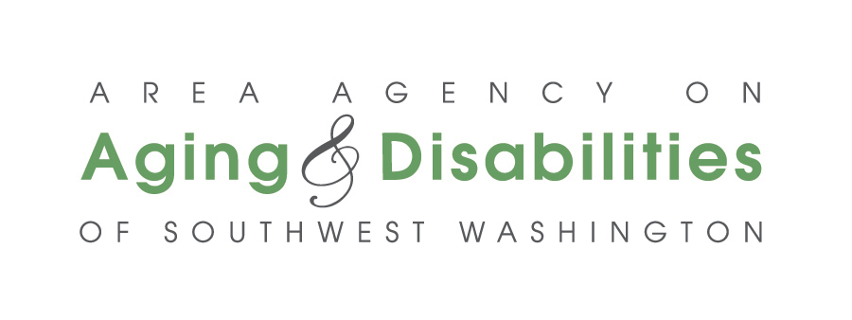
AGENDA
Council of Governments Board Meeting
Area Agency on Aging & Disabilities of Southwest Washington
Friday, May 29, 2026, 1:00 p.m. – 3:00 p.m.
- In-Person: AAADSW Office, 201 NE 73rd Street, Vancouver, WA – Columbia Room
- Join via Zoom: https://zoom.us/j/94804392921?pwd=bi8xTkxEZ0dRTzA4NU1uZXJQY0p4QT09
  - Meeting ID: 948 0439 2921 Passcode: 3PHkUw
- Join via Phone: 1-253-215-8782
  - Meeting ID: 948 0439 2921 Passcode: 140301

201 NE 73rd Street, Vancouver, WA – Columbia Room
Call To Order Commissioner Zoller

Pledge of Allegiance Commissioner Zoller

Agenda Review (Action) Commissioner Zoller

Review of Minutes (Action) Commissioner Zoller

Public Comment (limited to 3 minutes) Commissioner Zoller

Anniversary Recognition (Information) Mike Reardon

Advisory Council Update (Information) Apryl Schneider
Christina Marneris

Review of Financials (Information and Action) Claire Steiner

Resolution # 2026-1 Bank Accounts, to update AAADSW’s bank account Claire Steiner
check signers. (Action)

Resolution #2026-2, Investing Officers (Action) Claire Steiner

Director’s Report (Information) Mike Reardon

EXECUTIVE SESSION Commissioner Zoller

Good of the Order Commissioner Zoller

Adjourn (Action) Commissioner Zoller

