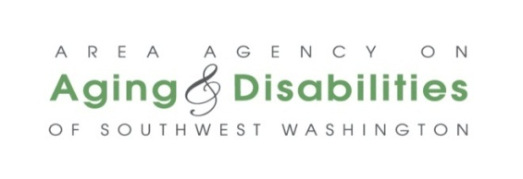

**AAADSW Advisory Council Meeting – April 16, 2025**

**Lunch: 11:30 am to 12:00 pm**

**Full Council Meeting: 12:00 p.m. – 1:30 p.m.**

* **Zoom Meeting:** [**https://us06web.zoom.us/j/81945103532?pwd=jvaTLrExf1Q71SMsPJFGv0NOablzqT.1**](https://us06web.zoom.us/j/81945103532?pwd=jvaTLrExf1Q71SMsPJFGv0NOablzqT.1)
* **Meeting ID:** **819 4510 3532**  **Passcode:** **2etQnG**
* **By Phone:** **1 253 215 8782** **Meeting ID:** **819 4510 3532 Passcode: 130626**

**AGENDA**

|  |  |  |  |
| --- | --- | --- | --- |
| **Time** | **Agenda Item** | **Action** | **Who Leads?** |
| 12:00 – 12:05 | 1. Call to Order/Roll Call Sign-In sheet 2. Approval of April 16, 2025 Agenda 3. Approval of March 19, 2025 Meeting Minutes | Motion to approve agenda  Motion to approve meeting minutes | Gavin Carmichael |
| 12:05 – 12:30 | Welcome Guests: Justin Ross, Clark County Commission on Aging  Announcements | Information | Gavin Carmichael |
| 12:30 – 1:00 | Reports   * Director’s Report * Executive Committee * Advocacy and Outreach | Information | Mike Reardon  Gavin Carmichael  Christina Marneris |
| 1:00-1:15 | MoWP Presentation (Clark County) | Information | Suzanne Washington |
| 1:15-1:25 | Housing Update | Information | Kevin Callahan & Christina Marneris |
| 1:25 – 1:30 | Public Comment | Information | Gavin Carmichael |
| 1:30 | Adjourn | ☺ | Gavin Carmichael |